**Quaternion (Mainly used for 3D Spatial Rotations)**

The representations of rotations by quaternions are more compact and quicker to compute than the representations by matrices. In addition, unlike [Euler angles](http://en.wikipedia.org/wiki/Euler_angles) they are not susceptible to [gimbal lock](http://en.wikipedia.org/wiki/Gimbal_lock). For this reason, quaternions are used in [computer graphics](http://en.wikipedia.org/wiki/Computer_graphics),[[11]](http://en.wikipedia.org/wiki/Quaternion#cite_note-11) [computer vision](http://en.wikipedia.org/wiki/Computer_vision), [robotics](http://en.wikipedia.org/wiki/Robotics), [control theory](http://en.wikipedia.org/wiki/Control_theory), [signal processing](http://en.wikipedia.org/wiki/Signal_processing), [attitude control](http://en.wikipedia.org/wiki/Attitude_control), [physics](http://en.wikipedia.org/wiki/Physics), [bioinformatics](http://en.wikipedia.org/wiki/Bioinformatics), [molecular dynamics](http://en.wikipedia.org/wiki/Molecular_dynamics),[computer simulations](http://en.wikipedia.org/wiki/Computer_simulation), and [orbital mechanics](http://en.wikipedia.org/wiki/Orbital_mechanics).

**Advantages of Quaternions**

[**http://www.gamedev.net/page/resources/_/technical/math-and-physics/do-we-really-need-quaternions-r1199**](http://www.gamedev.net/page/resources/_/technical/math-and-physics/do-we-really-need-quaternions-r1199)

Quaternions do better in rotation concatenation then other forms of representation

**History of quaternion**

So Hamilton had been thinking about Eulers formula for his 4D implementation

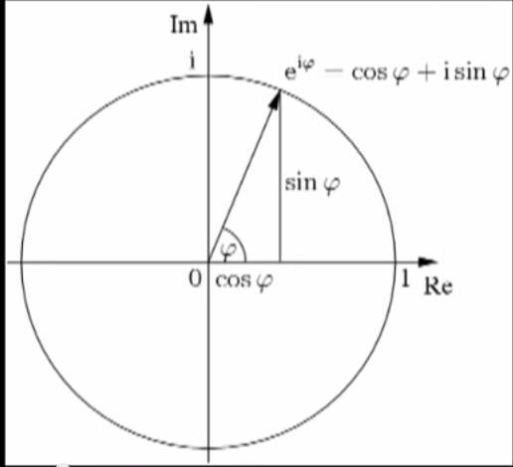

Multiplication and division for quaternion

*i*2 = *j*2 = *k*2 = *ijk* = −1,

so two more imaginary numbers (j,k) are invented to do quaternion math

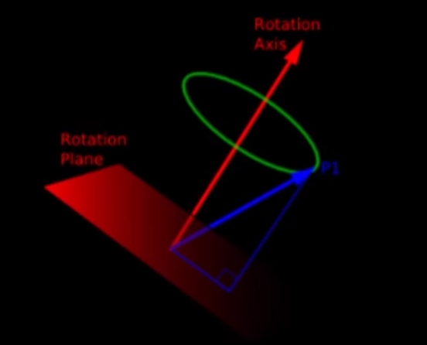

To rotate a point in 3D around an axis, we need to change the axis and point in to quaternion mechanics

**Quaternion definitions**

<http://www.cs.rpi.edu/~trink/Courses/RobotManipulation/lectures/lecture7.pdf>

**1D numbers -> Real numbers**

**2D numbers -> Complex numbers**

**4D numbers -> quaternions**

The quaternions, a number system that extends the complex numbers.

Hamilton’s quaternions are to R4 what complex numbers are to R.

1, I, j, and k are basis for quaternion in 4D vector space

That is , where *a*, *b*, *c*, and *d* are [real numbers](http://en.wikipedia.org/wiki/Real_number)

**Complex numbers vs quaternions**

Definition of complex numbers

1. Basic elements 1 and i
2. Elements have the form x+iy
3. i^2 = -1

Definition of quaternions

1. Basic elements 1,i,j,k
2. Elements have the form *a*1 + *bi* + *cj* + *dk*
3. *i*2 = *j*2 = *k*2 = *ijk* = −1,

ij = k

jk = i

ki = j

**Quaternion notation**

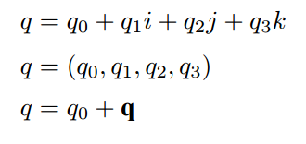

Where q0 is the scalar part, and q is the vector part

**Quaternion product**

Quaternions

**Rotation using unit quaternions**

Let q be a unit quaternions |q| = 1

It can be expressed as

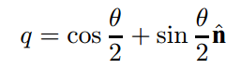

**Discussions**

**Do we Really need Quaternions?**

<http://www.gamedev.net/page/resources/_/technical/math-and-physics/do-we-really-need-quaternions-r1199>

**Why Diana Gruber’s wrong about Quats**

<http://www.gamedev.net/topic/25314-why-diana-grubers-wrong-about-quats/>